# Census Index and Crash Rates Dashboard Guide

# The census index presented in this dashboard combines twelve socio-economic factors using a Principal Component Analysis (PCA). PCA serves as a valuable dimensionality reduction technique frequently employed to streamline large datasets. It achieves this by transforming an extensive set of variables into a more compact one that retains a significant portion of the information from the original set, without sacrificing essential information.

# Socio-economic characteristics captured in the index include the following variables:

# Total Population,

# Educational Attainment,

# Median Age,

# Unemployment Rate,

# Industry of Employment,

# Health Insurance Accessibility,

# Population Living Below Poverty Line,

# Median Household Income,

# Housing Occupancy Type,

# Median House Value,

# Race, and

# Ethnicity.

# Five-year data profiles from the American Community Survey (ACS: 2017-2021) were downloaded at the county-level for the analysis. The above socio-economic characteristics were further integrated with crash rates, adding a critical dimension to the analysis, particularly in understanding how socio-economic factors correlate with traffic safety.

Crash rate metrics used in the dashboard include the following variables:

1. Crashes Per Population (per 1,000 population),
2. Crashes Per Vehicle Miles Traveled (VMT) (per 100 million VMT in 2021).

Crashes are fatal and suspected serious injury crashes (KA) from the years 2018-2022.

# Accessing and Using the Census Index Dashboard

The Census Index Dashboard is located on the TEXASTRCC.org website.

1. Click on the link to access the application: <https://texastrcc.org/census-index-and-crash-rate-dashboard/>
2. There are 3 interactive pages in the dashboard. The following is a list of the pages that present information by TxDOT District and County:

* Census Index and crash rates
* Census Index and data table
* City and roadway explorer

The crash data include fatal and suspected serious injury crashes only.

**Census Index & Crash Rates Page**

This page provides a visual representation of crash rate (normalized by population and traffic volume) and socioeconomic status to understand the association between the two. The association can also be visualized at TxDOT district levels.

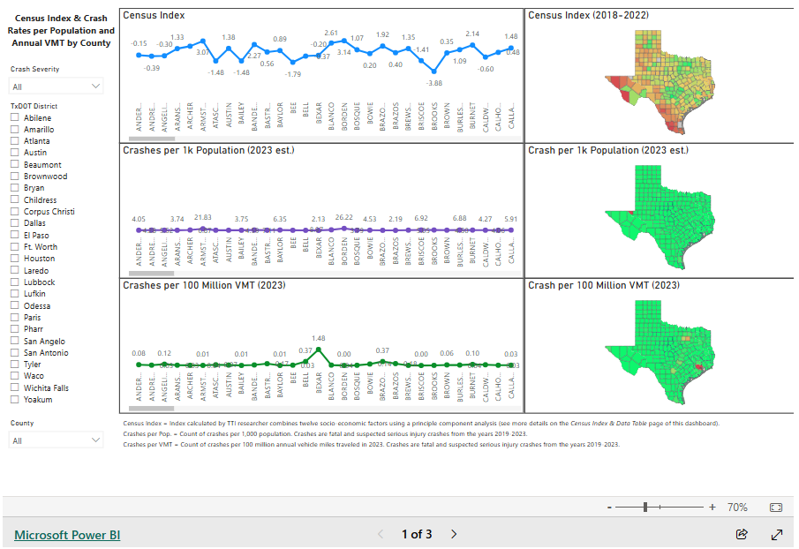

* Available filters: Crash severity (KA), TxDOT District, and County.
* Top chart and map illustrate the census index by county. The higher the number the more affluent the county. The map color coding is green (reflects counties with higher socio-economic status) to red (reflects counties with lower socio-economic status).
* Middle chart and map illustrate the crashes per 1,000 population rates by county. The population estimate is for 2020.
* Bottom chart and map illustrate the crash per 100 million VMT by county. VMT is currently for the year 2021 and was obtained from TxDOT’s multi year roadway data tables: <https://www.txdot.gov/data-maps/roadway-inventory.html>.

**Census Index & Data Table Page**

This page is helpful if the user wants to easily see crash rates for each county, all in one table.

* Available filters: Crash severity (KA), TxDOT District, and County.
* The table lists the census index, crash rate per 1,000 population, crash rate per 1 million VMT, count of crashes, estimated population, VMT, and the census index ranking by county. The higher the state index ranking the lower the socio-economic status of the county.
* The maps are the same as on the first page.

**City & Roadway Explorer Page**

This page is useful to explore the actual location of the crashes. After using one of the first two pages the third page can be used to identify locations within districts and cities where resources might be allocated.

* Available filters: Crash severity (KA), TxDOT District, County, and City.
* The map illustrates the crashes.
* Top table lists the street name assigned to the crash and the count of crashes.
* Bottom table lists the city assigned to the crash and the count of crashes.

# For other index-related details, please reach out to Nishita Sinha ([n-sinha@tti.tamu.edu](mailto:n-sinha@tti.tamu.edu)) or Marcie Perez (m-perez@tti.tamu.edu).