TRCC Executive Committee

Meeting Agenda

1:30-3:30 p.m. Tuesday, Jan. 26, 2021 – Microsoft Teams

1. **Call to order and distribution of sign-in sheet**
   1. Voice roll call and introductions.
   2. Remarks from TRCC Chair, Michael Chacon, P.E., TxDOT-Traffic Safety Div.
      1. There were 3,891 fatalities in FY 2020 which was the highest number experienced since 1984.
      2. TxDOT anticipated lower traffic volume and fewer fatal crashes associated with COVID-19 pandemic but unfortunately that did not happen.
   3. Remarks from Terry Pence, TxDOT-TRF-TS
      1. TxDOT recently received NHTSA Traffic Safety Facts reporting Texas crashes for the first nine months of 2020. All crashes were shown to be up by 4.6 percent with a significant impact in fatal and injuries collisions.
      2. The request for proposal (RFP) for traffic safety grants closed January 26, 2021 with a total of 291 proposals being submitted for consideration. TxDOT staff is in the process of reviewing and scoring the submitted proposals.
   4. Remarks from NHTSA (Becky Walker & Ken Copeland)
      1. NHTSA is reviewing the Texas Annual Report and anticipates the review to be complete by Friday January 29, 2021.
      2. NHTSA expressed thanks to TxDOT for the early submission of the Annual Report and was pleased with the content found so far.
   5. Remarks from FHWA (Ed Burgos-Gomez)
      1. FHWA indicated that their preliminary data assessment finds Texas to be in line with other states concerning the overall rise in fatal crashes and number of deaths.
      2. Most fatalities and deaths appear to be stemming from single vehicle crashes.
   6. Remarks from TRCC Moderator, Larry Krantz
      1. Mr. Krantz welcomed the TRCC to 2021 and remarked upon how the January 26, 2021 meeting marked one year of TRCC meetings being held remotely.
2. **TRCC Letter of Authorization (Krantz)**
   1. Mr. Krantz indicated that some TRCC members have provided their Department’s administrative letter of support acknowledging designated member participation in TRCC activities for FY 2021. It was further urged that members who have not submitted the letter of support to TxDOT should do so as soon as possible.
      1. Jim Hollis (TxDOT) suggested that the TRCC should provide an example letter of support from TRCC archives that could be replicated. It was decided that an example letter of support would be pulled and sent to the members for reference.
   2. The RFP for 2021-2022 Traffic Record Services proposals has been closed. The following is a list of proposals submitted to TxDOT for review, scoring and consideration:
      1. Improving crash records through identifying barriers and training law enforcement officers.
      2. TRCC.
      3. DPS-HSOC.
      4. DSHS emergency medical services and trauma registry.
      5. TMPS leaders project- streamline reporting process.
   3. TxDOT will present the Department’s scoring results and the committee members will vote at the March 30, 2021 meeting. Proposal information will be sent to the TRCC members prior to the vote.
   4. Approval of October 2020 TRCC Meeting Minutes
      1. Minutes were approved unanimously (Jim Hollis- motioned for approval; motion for approval was seconded by Lt. James Taylor).
3. **TRCC Member Roundtable (Krantz)**
   1. DSHS (Dan Dao)
      1. DSHS is still collecting data for the EMS Trauma Registry.
      2. DSHS reported that some COVID-19 patients are self-transporting to hospitals and parking/remaining outside of the medical facilities.
      3. DSHS is receiving 15,000 -20,000 COVID-19 records per day. The Department is updating their database to ensure timely reporting so information can be assessed by analysts. DSHS is also trying to determine if crash records are being linked to COVID-19 EMS calls for service. EMS first responders are being alerted to possible COVID-19 exposure risk when responding to calls for service involving roadway crashes.
      4. Dan Dao reported that he will be transitioning to another position and will no longer be participating as a member of the TRCC. Dan thanked Larry and TRCC for their support of DSHS and the EMS/Trauma registry project.

Many members of the TRCC wished Dan well and success in his future endeavors.

* + 1. Michael Spencer was named Dan Dao’s successor as the representative for DSHS on the TRCC.
  1. TxDMV (Tim Thompson**)**
     1. Mr. Thompson indicated that he is retiring from TxDMV and that this would be his last TRCC meeting. Many members of the TRCC wished Tim well and success in his retirement.
     2. The TxDMV has hired Roland Luna as their new Director. Mr. Luna will serve as the TxDMV’s representative to the TRCC until a new replacement can be made.
     3. The Texas Vehicle Performance Measures document was forwarded to Jon Graber at Texas A&M Transportation Institute (TTI). Any follow-up needing to be made on this document should be coordinated through Clint Thompson.
  2. DPS-DL (Angie Suarez)
     1. The DPS-DL HUB data base conversations are moving forward as planned.
     2. Ms. Suarez and her staff are getting acclimated to re-opening DL offices and distributing DL’s in light of COVID-19 pandemic.
  3. TxDOT-CRIS (Jim Hollis)
     1. January release 21.01 enhancements and maintenance have been performed on the CRIS system. This includes security updates, enhancing sign on options and authorizations for data retrieval.
     2. Additional enhancements to CRIS include:
        1. CR-3 code sheet updates.
        2. Added interpretive fields.
        3. Updated the servers to 2019 and Java.
     3. Upcoming CRIS releases for 2021 include developing spec spatial layer upgrades to true road bid in order to enhance crash location plotting, incident management, response time, and connectivity with system attributes and rules.
     4. Crash Records is reviewing and interpreting new legislative mandates that will require CR3 form modifications.
     5. The Data Analysis Team is striving to enhance system visualization tools and public/stakeholder/Departmental access to the CRIS data through the DIR Open Portal.
     6. Crash Records continues to provide support analytics for the Departments Highway Safety Improvement Plan (HISP) and Highway Safety Plan (HSP).

1. **Presentations from** **David Freidenfeld, TxDOT-TPP**
   1. Mr. Freidenfeld indicated that TPP is in the process of closing down the 2020 data year. TPP is working with the TxDOT Information Technology team to improve the GRID roadway database.
   2. Bill Knowles (Director TPP) retired in November and Mr. Freidenfeld is filling the leadership role for TPP as interim until a full-time replacement can be named.

**Presentation-** **David Freidenfeld, (TxDOT-TPP)**

*“Weight in Motion (WIM) and Vehicle Classification (VC) Strategic Plan”*

* + 1. The goal of the project is to evaluate existing WIM and VC data collection efforts and to identify opportunities to enhance support of TxDOT goals. Additionally, the project personnel are assessing how to better build partnerships/collaborations with stakeholders to increase data sharing.
    2. Main purpose of the strategic plan is to improve safety and mobility, collect and share data for planning engineering operations and maintenance policies, manage project costs and mitigate damage to State highway systems. The plan will generate data that can be used to inform decision making to improve safety and mobility statewide, improve operations, and foster economic competitiveness for the state.
    3. WIM and VC systems are data collection technologies that measure the dynamic weight of a vehicle and its axles as it passes over roadway sensors. WIM and VC being used for pavement and bridge design, safety analysis, congesting analysis, air quality and noise analysis, and freight planning and logistics/management.
    4. Presently there are 37 permanent WM sites; 125 permanent VC sites for 80,000+ on system centerline miles.
    5. Current weight station and border inspection facilities using WIM and VC technology= 100 weigh station locations and 8 border inspection facilities.
    6. Between 2016-2019 there has been a 34% increase in OS/OW single use permits. This suggests an increased need in better understanding weight and roadway system use to forecast future maintenance needs. The WIM and VC technology supports that effort.
    7. WIM and VC project goals for Texas include:
       1. Establish sustainable maintenance program to support WIM/VC system,
       2. Expand system to reassure comprehensive coverage.
       3. Collaborate with internal and external stakeholders to enhance effectiveness.
       4. Streamline data management and accessibility to support end user needs.
       5. Leverage emerging technology and real time data to expand WIM/VC functionality.
    8. TPP is anticipating the project to close out by the end of spring (May) or early summer.
  1. **Presentation**- **David Freidenfeld (TxDOT-TPP)**

*COVID Travel Trends*

* + 1. Presentation detailed post COVID travel trends with regard to traffic volumes and speeds.
    2. Benchmark low was in February and as people became more comfortable with traveling again, there was an increased traffic volume going into March 2020. The daily traffic volume trend stabilized in May 2020 and then grew steadily through June 2020. The daily traffic volume has remained at near 90% through November 2020.
    3. Mr. Freidenfeld indicated that the state is back to normal with regard our daily traffic volumes as compared to before COVID-19 struck.

1. **Presentation- Lt. James Taylor (DPS-HSOC)**

*COVID-19 Travel Restrictions- Impact on Crash and Enforcement Trends in Texas*

* + 1. Focus of the presentation centered on DPS enforcement actions that took place during the height of COVID-19 (March 19th, 2020 – May 1, 2020). Lt. Taylor highlighted enforcement trends within the COVID-19 period and compared them against pre-COVID-19 years (5-year aggregate).
    2. The analysis indicated a shift in THP enforcement efforts moving from predominantly Friday/Saturday (pre-COVID) to enforcement during the middle of the week (Wednesdays) during peak COVID-19 periods.
    3. Overall, THP enforcement actions decreased by 70% for all violations with an increased issuance of no driver’s license/unlicensed and fail to maintain financial responsibility.
    4. Non-crash related enforcement actions also decreased during peak COVID-19 period by 71%. No driver’s license/unlicensed driver violations increased as did failure to drive in single lane.
    5. Crash related enforcement actions also decreased during the COVID-19 period by 25%. Most crash related enforcement actions that showed an increase were unsafe speed and no driver’s license.
    6. The total number of crashes saw an overall decrease in occurrence, however there were no reductions in the overall number of fatal and injury crashes when compared to the previous five years of data. This occurring even as there were lower volumes of traffic on the states roadway system.
  1. Several TRCC members asked for copies of the presentations that were given during the meeting. Presentations will be provided to the TRCC Chairman and distributed upon request and as attachments to the 01/26/2021 meeting minutes.

1. **Parting Comments**
   1. HSOC Update- Citation data integration has been completed and is now part of the system. While the data is not retro-active, it does provide a snapshot of citation information (James Taylor- TxDPS).
   2. Next meeting- TRCC membership will discuss the results of scored traffic records proposals and will vote on moving projects forward based on need (Larry Krantz)
2. **Adjourn**
   1. Next TRCC Meeting will convene at 1:30 p.m. on Tuesday, March 30, 2021

**Attendees:**

Angie Suarez (TxDPS-DL)

Larry Krantz (TxDOT)

Troy Walden (TTI)

Brittany Congdon (TxDPS-HSOC)

Lt. James Taylor (TxDPS)

Kenneth Copeland (NHTSA)

Jim Hollis (TxDOT)

Eddie O’Connor

Rebecca Walker (NHTSA)

David Freidenfeld (TxDOT-TPP)

Terry Pence (Tx DOT)

Jessica Son

Michael Chacon (TxDOT)

Jeremy Upchurch

Tim Thompson

Michael Spencer (DSHS)

Pierce Baumann (DSHS)

Ed Burgos-Gomez (FHWA)

Dan Dao (DSHS)

Larbi Hanni (TxDOT)

Carol Campa (TxDOT)

George Villarreal

Jeremy Upchurch

John Garza (TxDPS)

Nicole Tyler

Jodie (Guest)

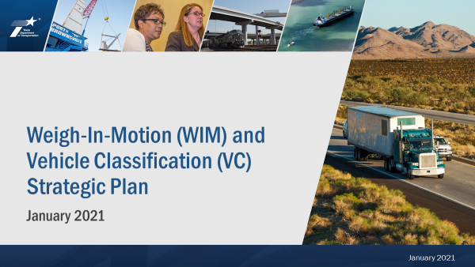

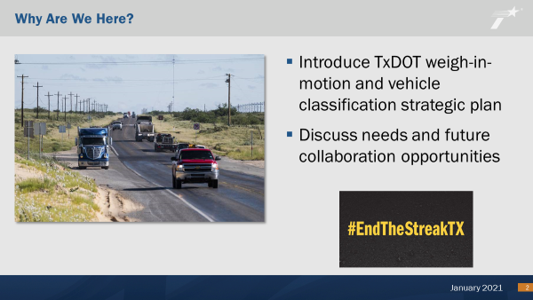

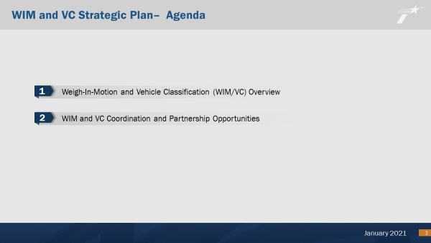



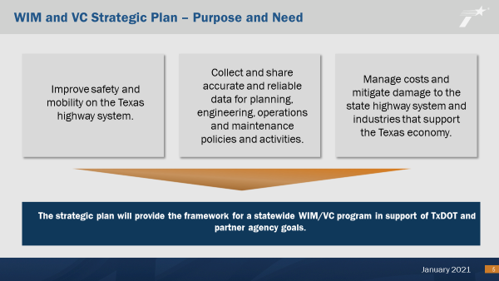

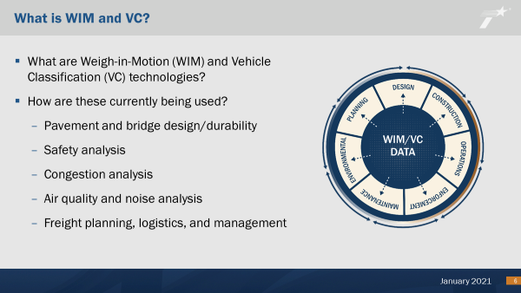

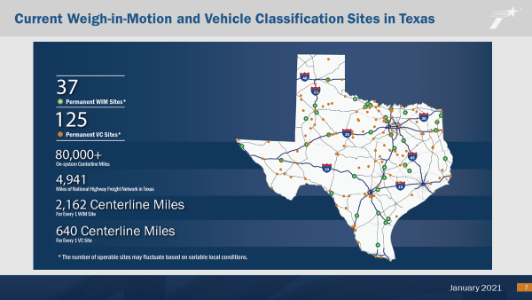

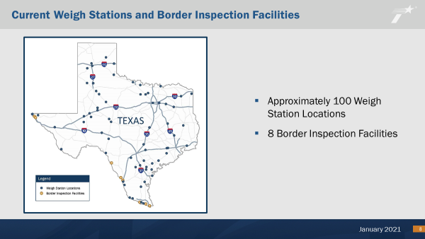

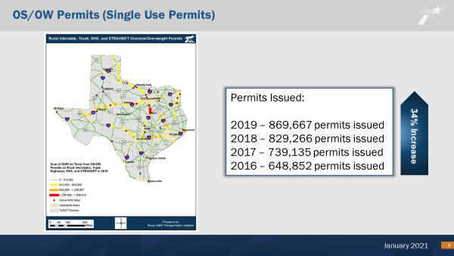

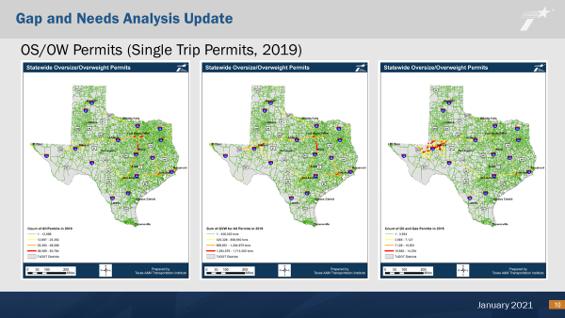

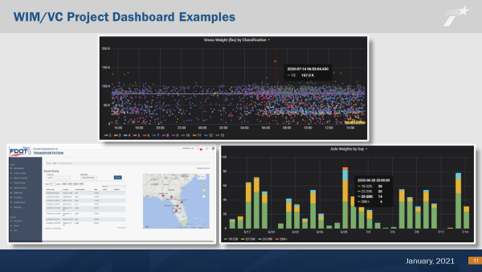

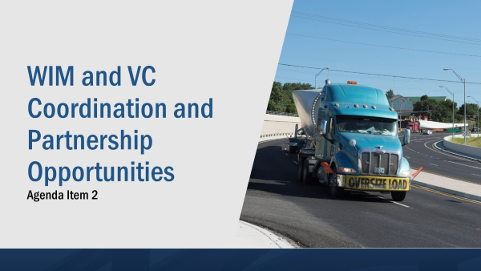

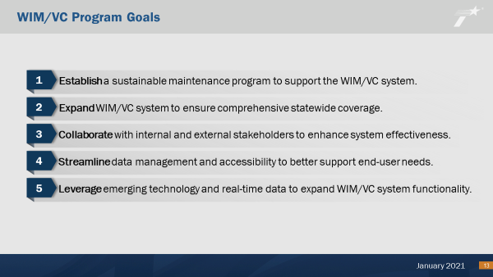

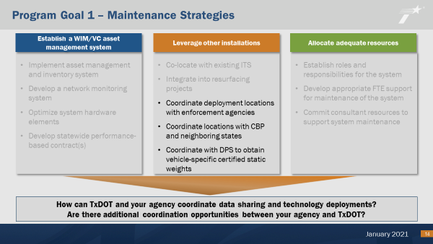

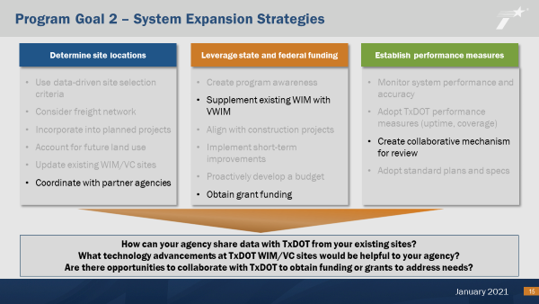

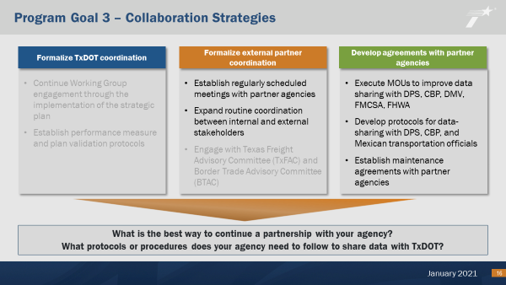

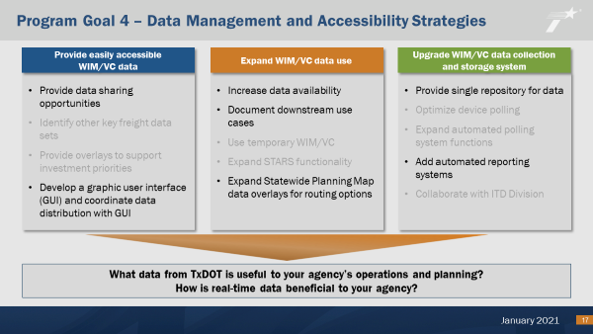

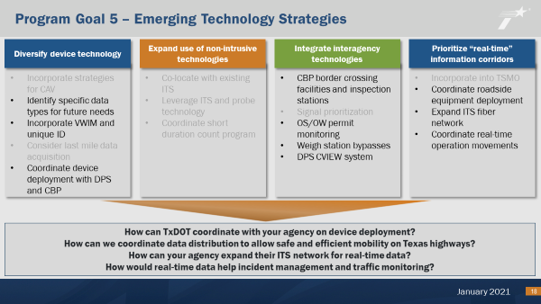

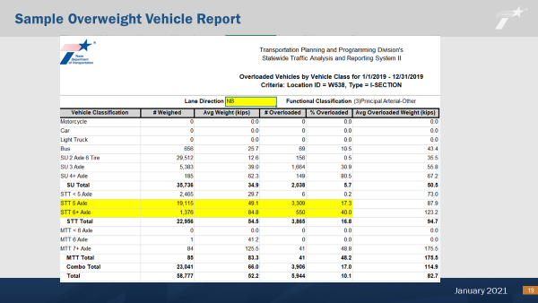

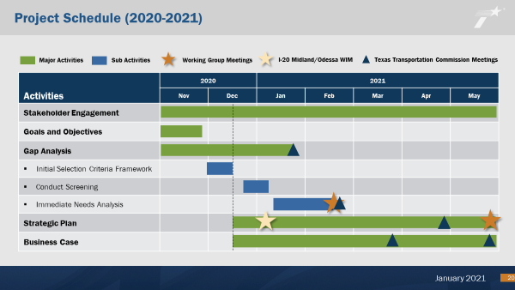

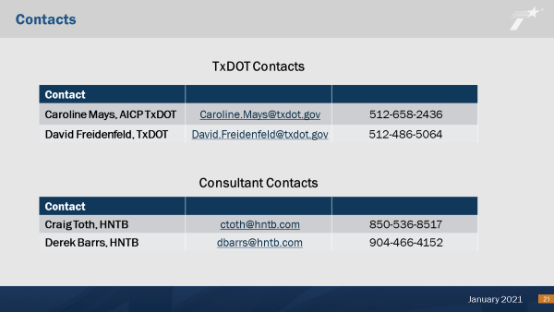

Page Intentionally Left Blank



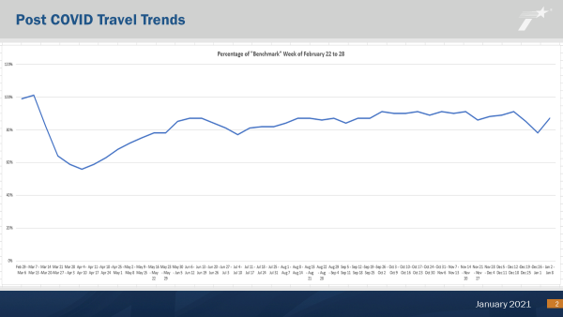

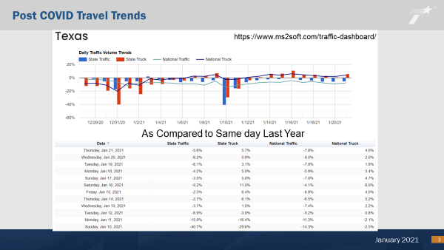

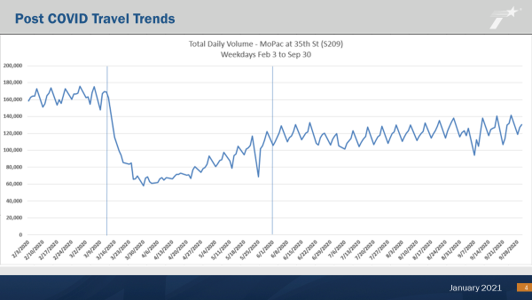

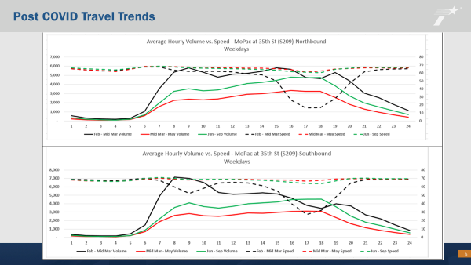

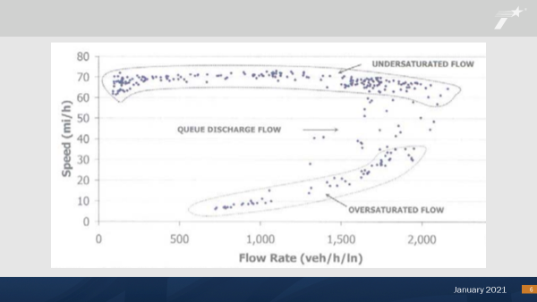

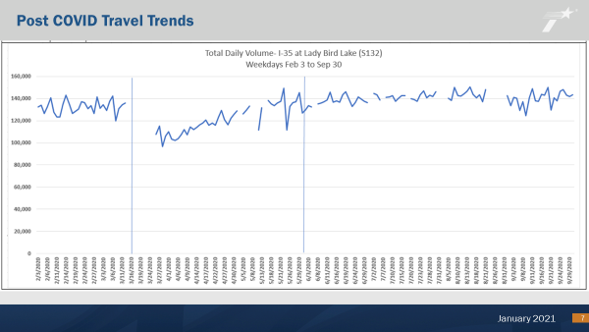

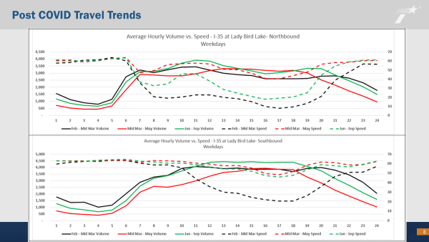



Presentation Sides for:

COVID-19 Travel Restrictions- Impact on Crash and Enforcement Trends in Texas.

*Pending- awaiting TxDPS approval for release.