Background
MicroStrategy (MSTR) - The business intelligence software that is connected to the CRIS database and used to pull crash data, generate reports and dashboards.

To prepare for and take MicroStrategy (MSTR) training, TxDOT has created procedures for the user.

Agency Breakdown Counts by Role Types
TxDOT recommends the following breakdown counts by group for agencies.
• Report Users – 10 per agency
• Report Analysts – up to 2 per agency

Role Description
Please feel free to provide feedback of the CRIS MicroStrategy Online Training course to TxDOT CRIS Support Team at TRF_CRASH@txdot.gov.

MSTR Roles:
- Report User – This user will log on to MSTR and will only see the Investigating Agency folder and will only be able to run published reports that are available in that folder. This user will not be able to modify the reports in design mode or create reports. Review of the following MSTR chapters is recommended for this group. The user does not have to complete a test.
    - Chapter 2. Introduction to MicroStrategy Report Terminology
    - Chapter 3. Introduction to the MicroStrategy Web Interface
    - Chapter 4. Accessing a MicroStrategy Web Project
    - Chapter 9. Setting Preferences
    - Chapter 11. Executing Prompted Reports
    - Chapter 15. Using Full Screen Mode in Reports
    - Chapter 16. Using Go to Another Page (Incremental Fetch)
    - Chapter 20. Sorting Report Data
    - Chapter 24. Re-prompting Reports
    - Chapter 25. Printing
    - Chapter 26. Using the History List
    - Chapter 27. Exporting Reports
    - Chapter 33. Subscribing to Reports
    - Chapter 43. Adding Reports to the History List
- Report Analyst – Enables the ability to run published reports and create reports using CRIS MicroStrategy. This access requires the completion certificate of “CRIS MicroStrategy Online Training at https://www.txdotcrash.com/crash/ under Training and Microstrategy. Once the test is passed, please send in the completion.

Procedures
Once you decide which role(s) would be suitable for you, please proceed with the below necessary steps to gain access to MSTR.

Report User
- Read required chapters from the TTI CRASH website (https://www.txdotcrash.com/).
- Access MSTR link via the following URL: https://cris.dot.state.tx.us/secure/microstrategy/asp/
- Select your agency and log in.
- You will get a blank MicroStrategy page (see below screen print), which will create your profile and allow TxDOT to give you access to the crash data project.
- Capture a screen shot of the blank MicroStrategy page.

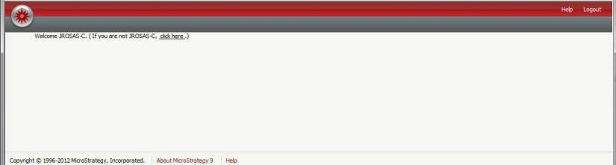

- Submit an email to the CRIS Support Team at TRF_CRASH@txdot.gov and include:
  - Screen shot of the blank MicroStrategy page
  - Your user ID or log in name
  - MSTR Role desired
  - Completed External CRIS User Confidentiality Agreement
- Once your user is granted access you will receive a confirmation e-mail.

Report Analyst
- Read required chapters from the TTI CRASH website (https://www.txdotcrash.com/).
- Take quizzes and final exam (A score of 75 or above is passing.)
- Capture a screen print of the passing screen, with the certification number.
- Access MSTR link via the following URL: https://cris.dot.state.tx.us/secure/microstrategy/asp/
- Select your agency and log in.
- You will get a blank MicroStrategy page (see below screen print), which will create your profile and allow TxDOT to give you access to the crash data project.
- Capture a screen shot of the blank MicroStrategy page.

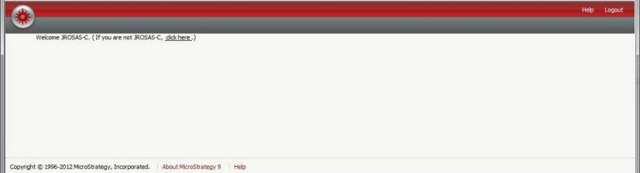

- Submit an email to the CRIS Support Team at TRF_CRASH@txdot.gov and include:
  - Screen print of the passing score, with the certification number
  - Screen shot of the blank MicroStrategy page
  - Your user ID or log in name
  - MSTR Role desired
  - Completed External CRIS User Confidentiality Agreement
- Once your user is granted access you will receive a confirmation e-mail.

Contact Information
If you have any questions, regarding the role options and / or steps to gain access you can contact the CRIS Support Team at TRF_CRASH@txdot.gov or 512-416-2902.

If you have already established access and have questions regarding MicroStrategy use, you can contact the CRIS Help Desk at support@crishlp.com or 844-CRISHLP (844-274-7457)

